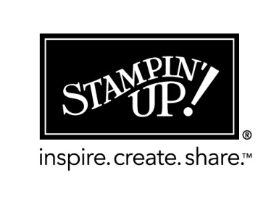
my wish list – Glitter Window Card

Name ___________________________________

 | item # | description
 |  | STAMP SET
 | 130634 | Chalk Talk Stamp Set clear-mount
 | 132730 | Chalk Talk Bundle clear-mount
 | 130631 | Chalk Talk Stamp Set wood-mount
 | 132731 | Chalk Talk Bundle Wood mount
 |  | CARDSTOCK
 | 119685 | Cherry Cobble 3 ½“ x 8”
 | 126840 | Gumball Green 3 ¼” x 3 ¾”
 | 100730 | Whisper White 2 ½” x 2 ½”
 | 127885 | Champagne Glimmer Paper
 |  | INK
 | 126966 | Cherry Cobbler
 |  | Other
 | 119858 | Boho Blossom Punch
 | 102023 | Dazzling Diamonds Glitter
 | 121003 | Glimmer Breads Basics
 | 129983 | Chalk Talk Framelits
 |  | Stampers Essentials
 | 104332 | Snail Adhesive
 | 103683 | Glue Dots
 | 104430 | Dimensionals
 | 103579 | Paper Snips (scissor)

You can order 24/7 at my online store just visit www.stampstodiefor.com
And click the SHOP NOW button
or email me at stampstodiefor@gmail.com
Supplies from the 2013-2014 Stampin’ Up! Annual Catalog & Holiday Mini Catalog

